Descriptive Analysis of FIFA 2019 Players.

We will be looking at the data set and exploring stuffs along with creating the structure of table and querying it to derive the answers to our questions.

1. **Dataset Access.**

Data set can be accessed by clicking following FIFA_2019.csv file.



1. **Data Dictionary.**

We will check here what exactly each column of our dataset means.

|  |  |
| --- | --- |
| Name | Description |
| ID | Identity of person |
| Name | Name of the player |
| Age | Age of the player |
| Nationality | Player’s Nationality |
| Potential | Potential Rating |
| Overall | Overall Rating |
| Club | Club for which player plays |
| Value | Current market value in euros |
| Wage | Current wage in euros |
| Preferred Foot | Preferred foot for playing |
| Jersey Nos | Nos on the jersey |
| Joined | Joined Date |
| Height | Height in foot and inches |
| Weights | Weight in pounds |

1. **Question Addressed.**

There can be varieties of the questions which can be address by looking at the dataset which we will be deriving its answer by MySQL. It can be accessed by clicking following Questionaries.txt link.



1. **Loading Data in MySQL.**

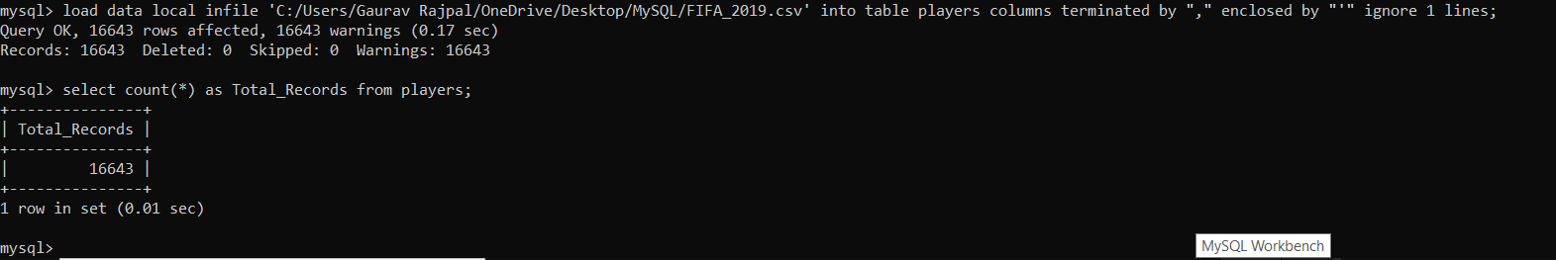

1. **Answering Simple Queries.**

* To get the count of records in the table.

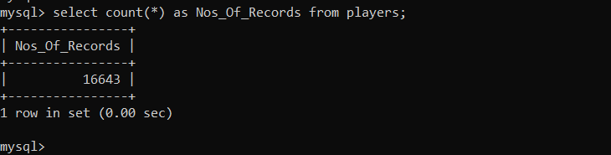

* How many nationalities do we have?

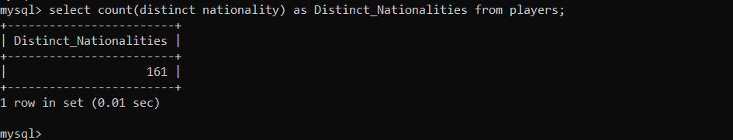

* Which nationality has more number of players?

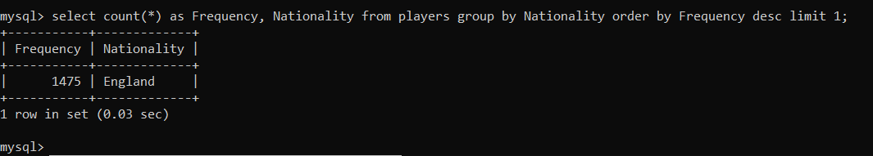

* What are the top 3 nationality by number of players?

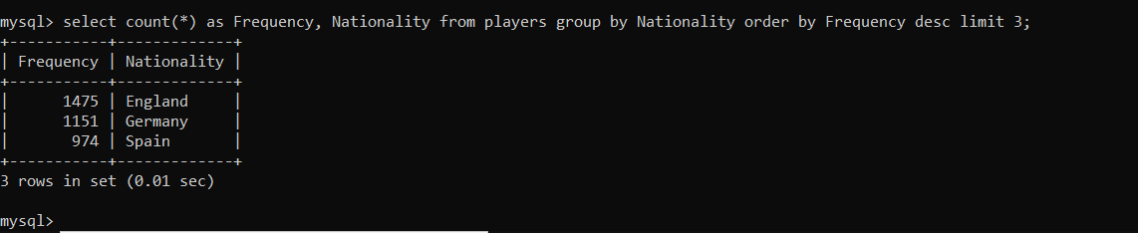

* Which player has highest wage?

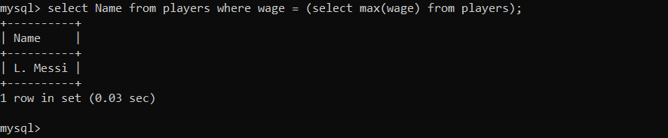

* How many players are having lower wage?

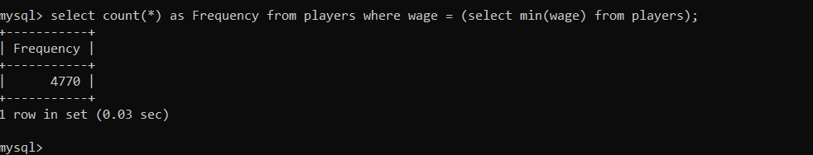

* Which players have best overall rating?

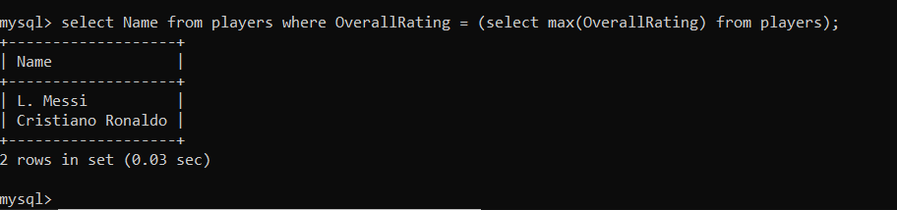

* Which player has lowest overall rating?

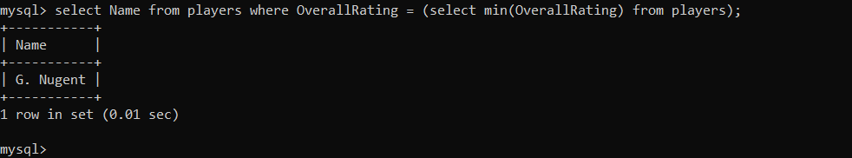

* Which club has highest overall rating?

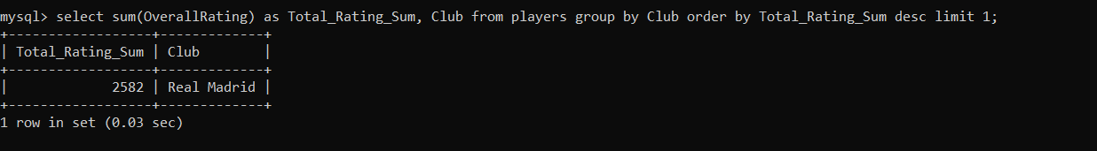

* Which are top 5 clubs based upon the average rating of the players?

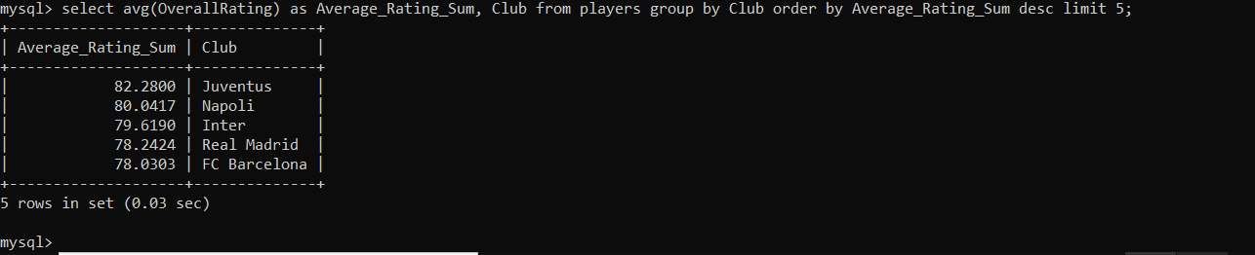

* What is the distribution of players who preferred left foot vs right foot?

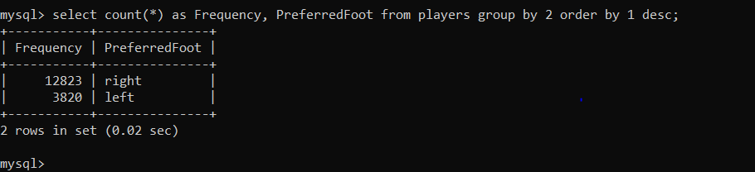

* Which jersey number is luckiest (Considering total wages as luckiest parameter)?

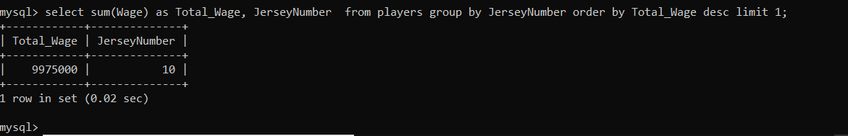

* What is the frequency distribution of the nationalities?

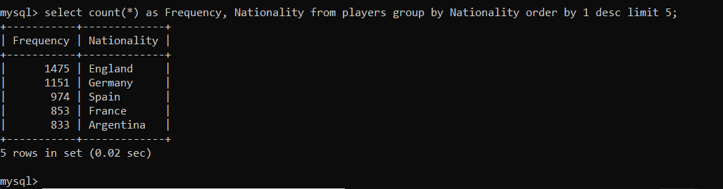

* What is the distribution of height of players?

